UI/UX

Scanner
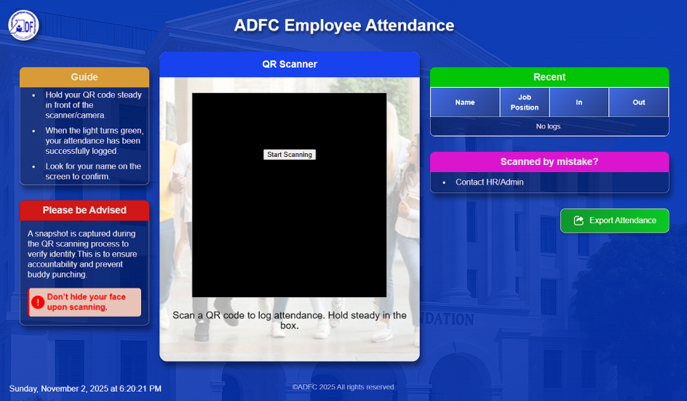

Login Page
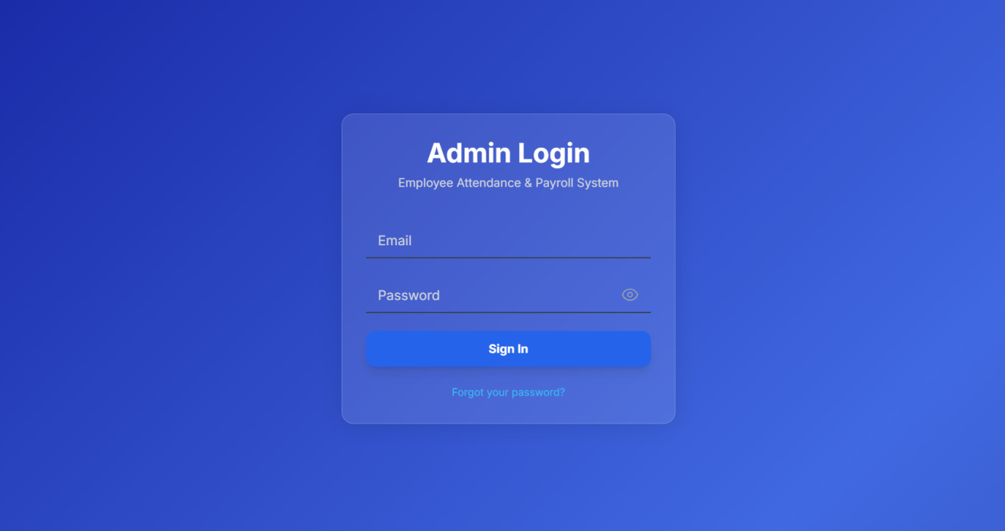

Admin Dashboard
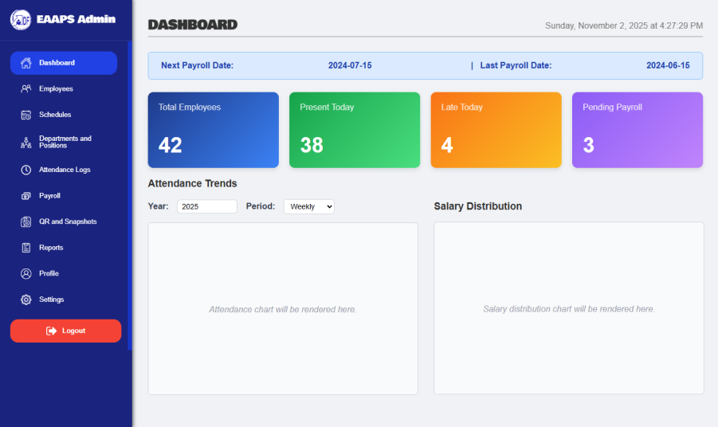
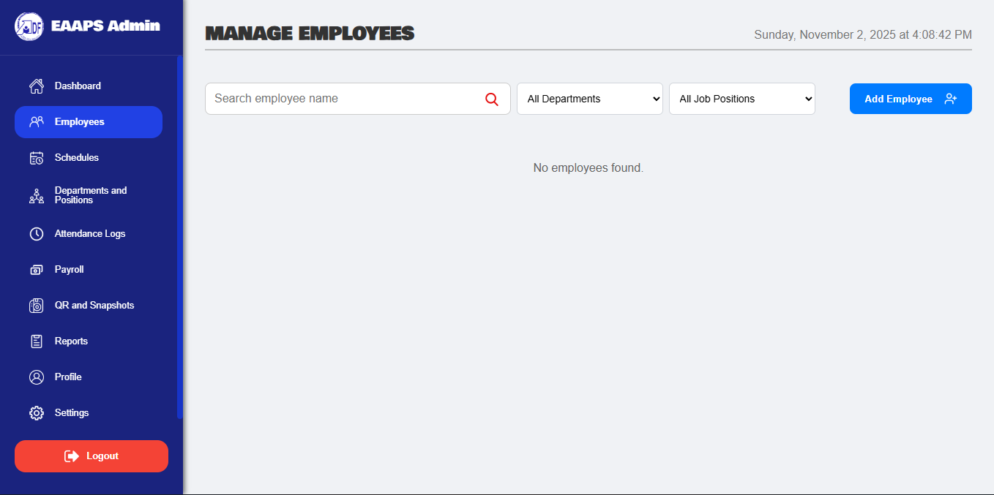
Employees Page

Schedules Page
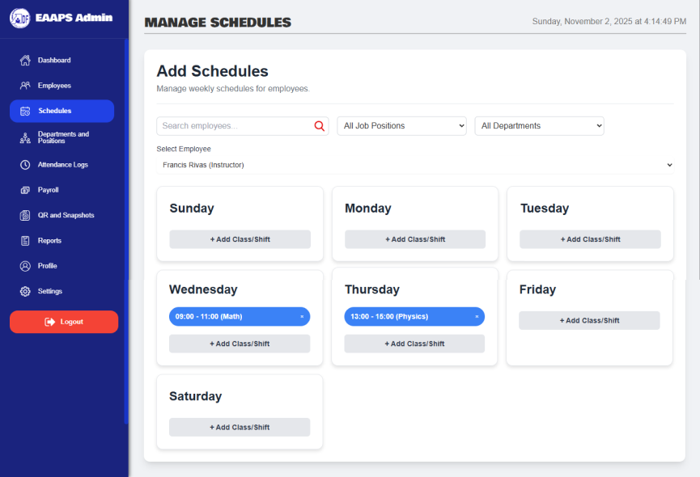

Departments and Job Positions Page
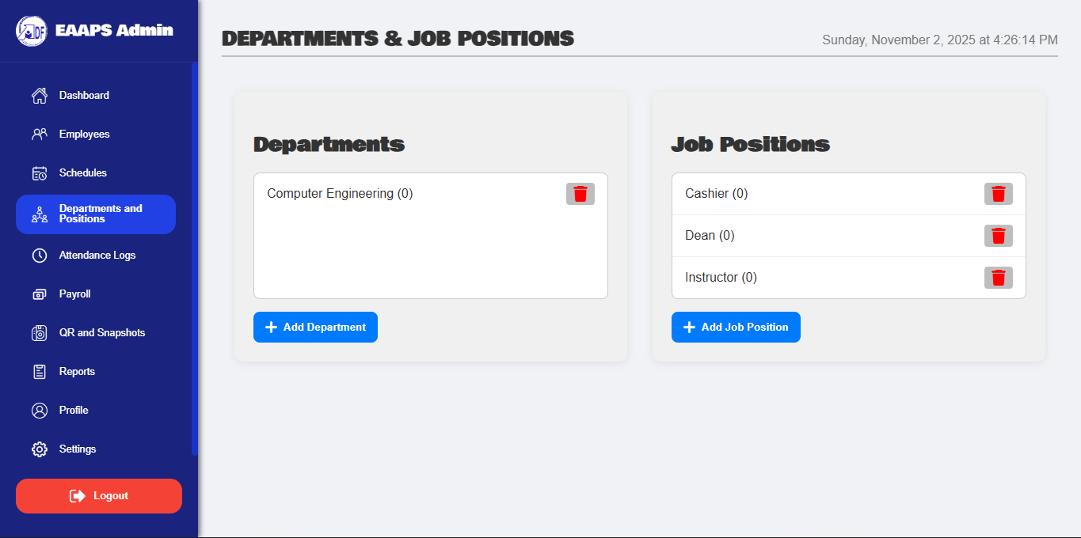

Attendance Logs Page
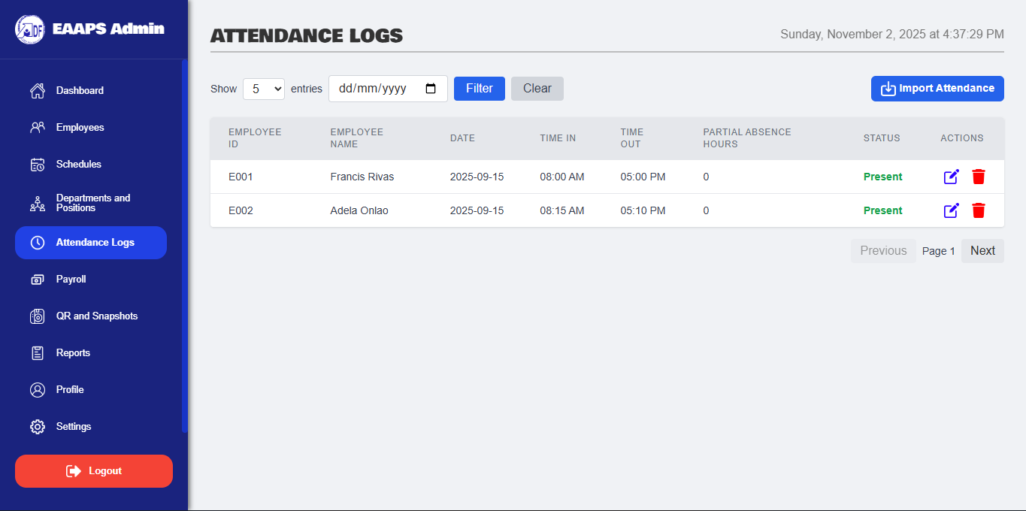

Payroll Page
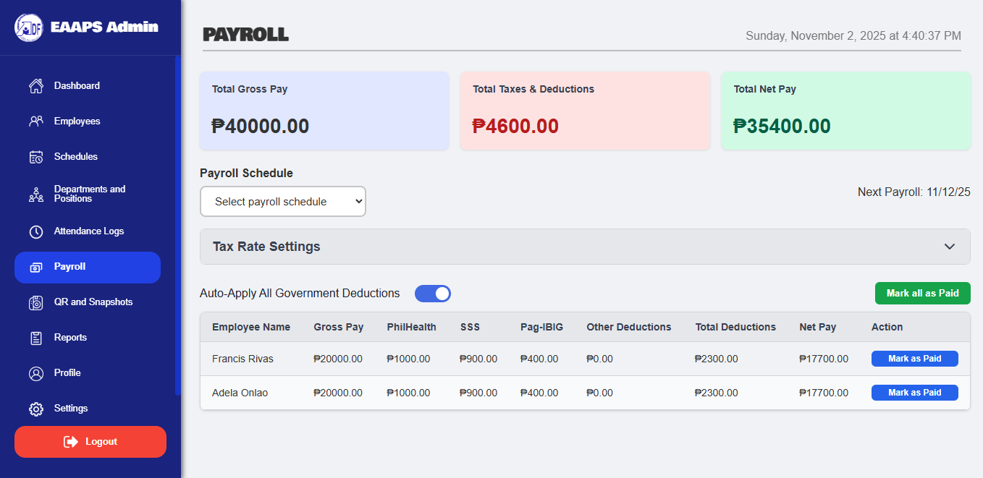

QR and Snapshots Page
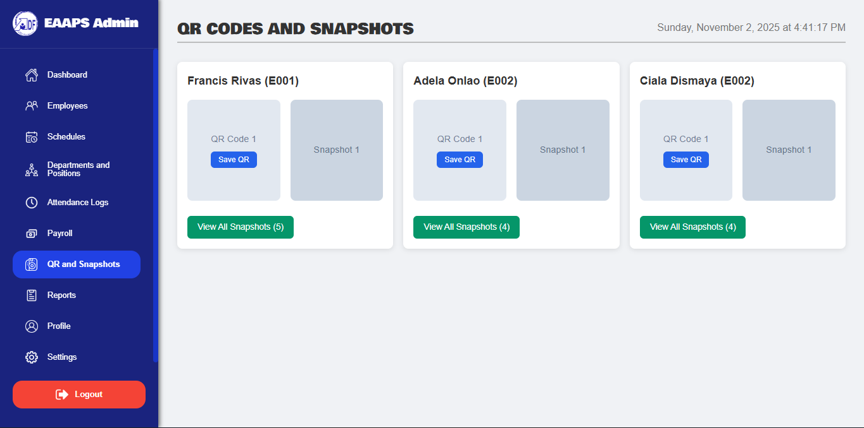
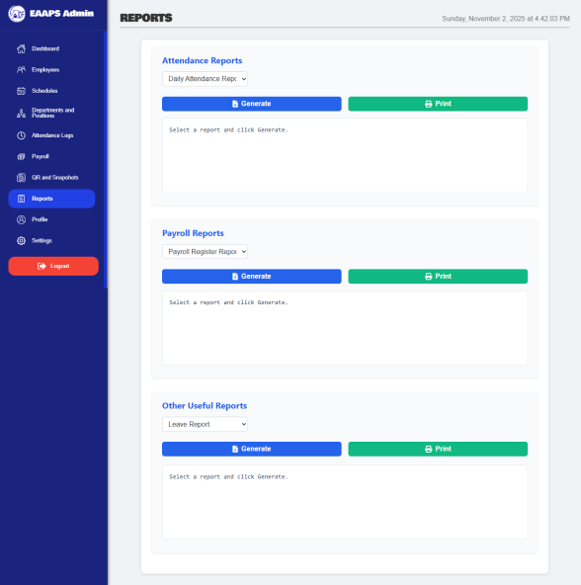
Reports Page

Profile Page
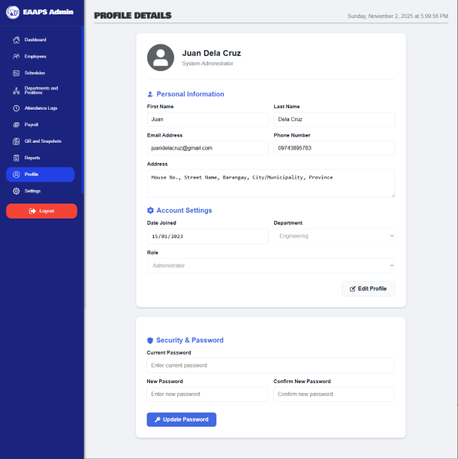

Settings Page
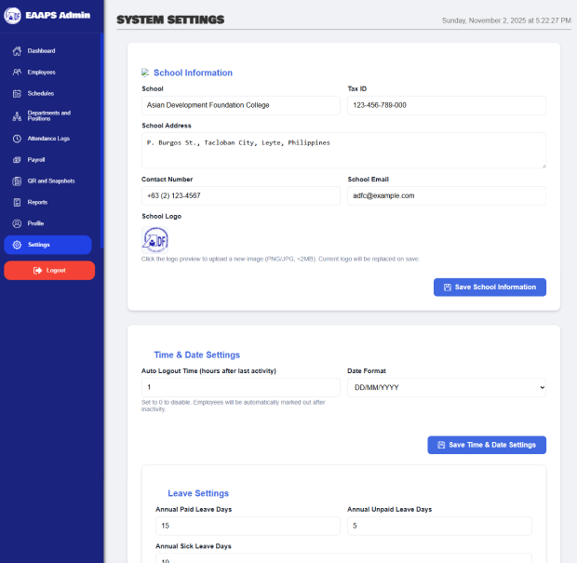

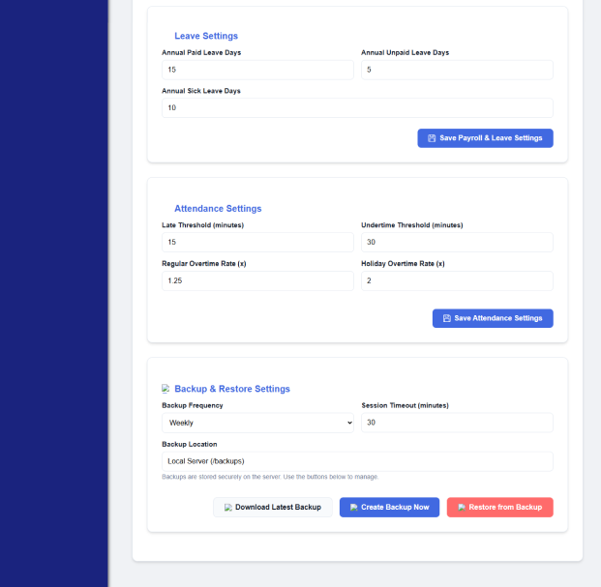

Use Case Diagram
Employee Attendance and Payroll System
Manage Setup Data
Login to System
Manage Departments & Position
Manage Employees
Manage Schedule
Import Attendance Logs
Monitor Attendance Logs
Compute Payroll
View QR codes and snapshots
Print Reports
Generate Reports
Calculate Overtime
Apply Deductions
View own Attendance
View Payslip


Admin

Employee

ER Diagram

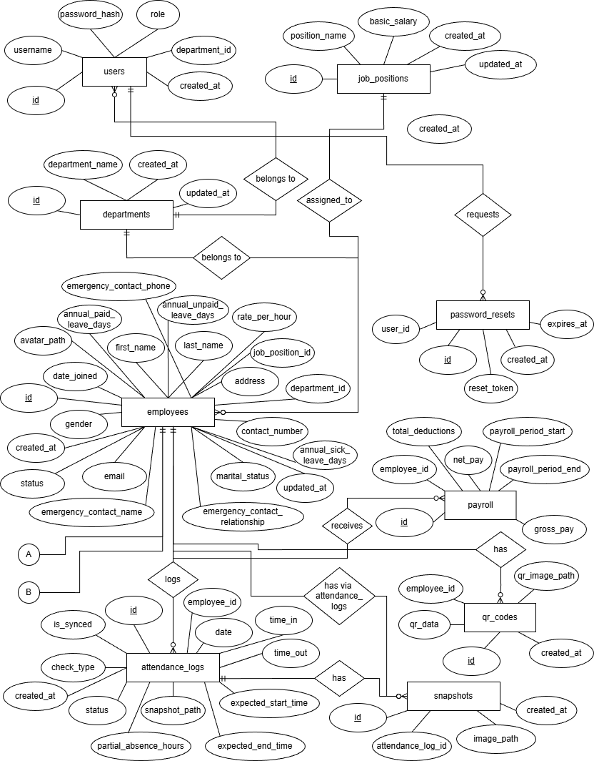

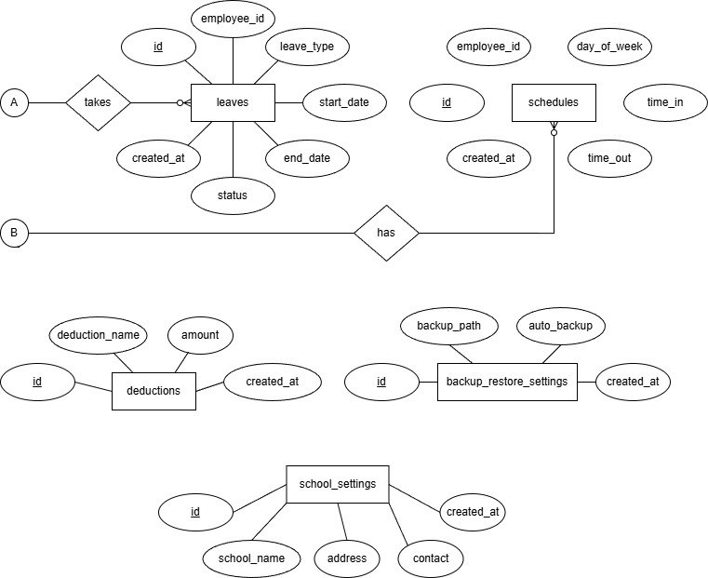

START

Admin Login Page

View Dashboard (Stats Summary)

Choose Menu Option:
Employees/ Schedules/ Attendance/ Payroll/ QR Snapshots/ Reports Profile/ Settings

Perform Action
(CRUD or View)

Generate/Print Reports?
NO
YES

Logout/Exit
Display & Print Reports

END

